Monso's Idol Shop Puppet Show

"Monso's Idol Shop" is a puppet show which demonstrates the fear that is very real to many people in Africa who hold to animistic beliefs. Animists believe that there is a God, but that He lives so high up in Heaven that it is hard to reach Him. They also believe that there are good and bad spirits that dwell here on earth, which are responsible for whatever happens (good or bad) in their lives. Since it is the bad spirits that cause problems (such as drought, poverty, sickness, injury, and death) the animists are very afraid of the bad spirits, and spend a great deal of time and effort in trying to appease them and keep them happy so that the bad spirits will not harm them in any way. This puppet show teaches about the worthlessness of idols, and teaches about the power of Jesus, His sovereignty over ALL spirits, and how we can be delivered from fear by putting our trust in Him.

Needed Supplies:
-- Script for the puppet show (or the audio recording, available for free download)
-- Puppet stage
-- 2 hand puppets (a father and a son, preferably African looking)
-- 5 eggs
-- Sewing needle or a strong pin
-- Acrylic paints (assorted colors)
-- Paint brushes
-- Small cardboard box (about 12-inches by 12-inches)
-- 2 toilet paper rolls
-- Scissors
-- Elmer's glue
-- A small stick (about 3 inches long)
-- Lid to a small tomato paste can
-- Floral crafters wire
-- Permanent marker

Props:
In order to put on this puppet show, you are going to need to make a few props: 5 idols, an idol stand, and an axe.
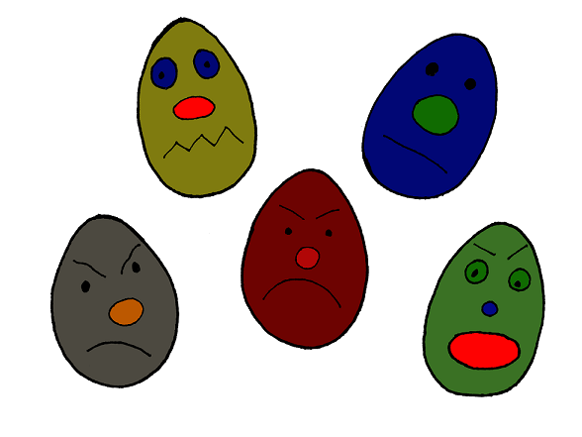
To make the idols:
1) With a sewing needle or a strong pin, poke a hole in the top and bottom of an egg. Blow through one of the holes so that the egg white and egg yolk will come out the other end. Be careful not to crack the egg. Blow as much of the egg out as possible. Then rinse well and set aside to dry. Do this for all 5 eggs.
2) Once the hollow eggshells have dried, paint them all sorts of different colors, giving them unpleasant looking faces.

To make the idol stand:
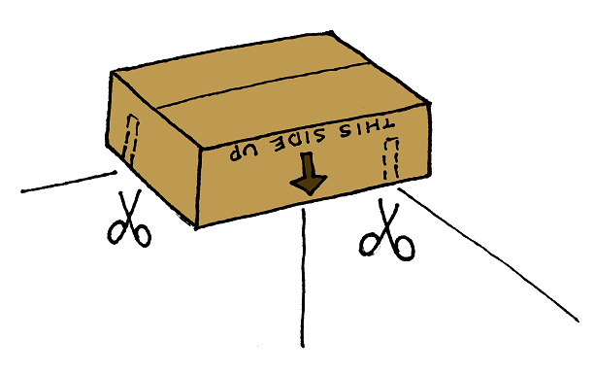1) Take a small box and fold all the flaps inside.
2) Turn the box upside down and fit onto the corner of the puppet stage to test and see where the slits will need to be cut in order to make the box fit onto the puppet stage.
3) Cut slits on two sides of the box, to make the box fit securely on the puppet stage.
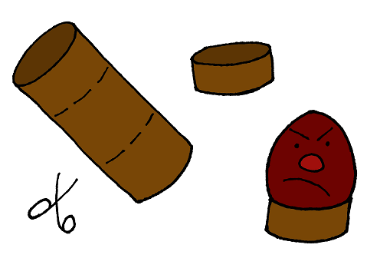4) Take two toilet paper rolls. Cut one of the rolls into thirds (so that you have 3 round pieces). Cut the second toilet paper roll into 2 pieces (one round piece the same size as the other three, and the second round piece noticeably bigger than all the others)
5) Glue these round pieces to the bottom of the box, with the largest round pieces in the center, and each of the 4 smaller pieces in each of the 4 corners of the box.
6) Paint the box to cover any writing or lettering that may be showing.
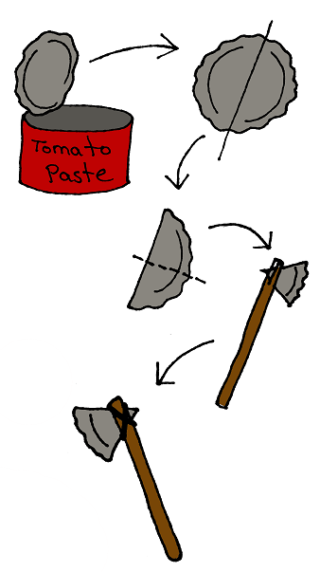7) With a permanent marker, write the words "Monso's Idol Shop" on the side of the box that will be facing the audience.

To make the axe:
1) Using a can-opener, cut the lid off of a tomato paste can. Wash the lid so it is clean.
2) Cut the lid in half. Take one of the two halves of the lid and fold it in half to form a triangle (this is the axe head)
3) Cut a slit in the end of a stick and slip the narrow side of the triangle into the slit. Use floral crafters wire to bind the stick and the metal triangle together so they will not come apart. If the axe head is still very loose, you may need to use a hot glue gun to secure it properly.

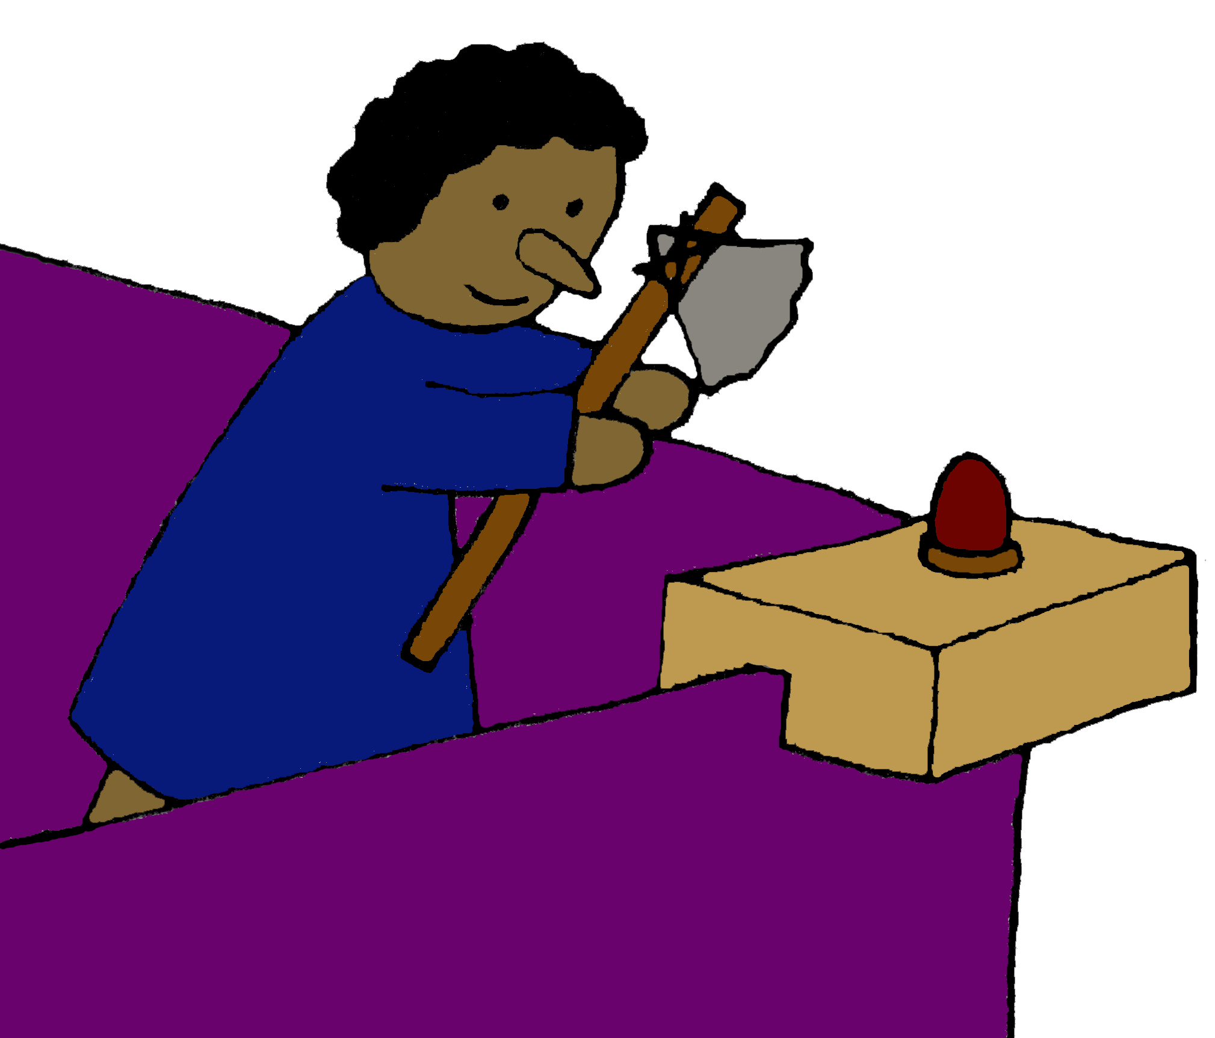

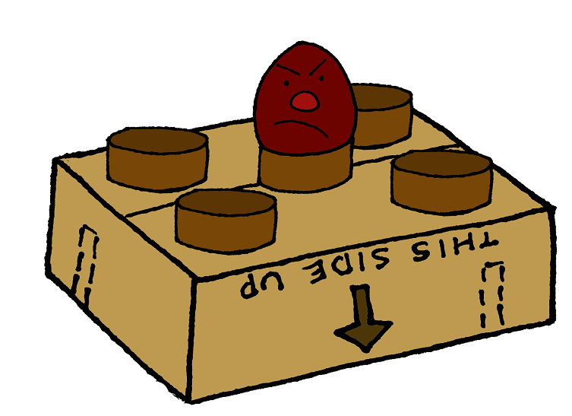
Monso's Idol Shop Script

Monso: (Stroking idols with the axe, as if carving them. Then he sets the axe down on the stand and steps back to admire his work) There! That idol is finished. But where is my lazy son Fodie? He should have been here a long time ago to help with this work. Sometimes I am very sorry that I let him go to that missionary school. His head is full of nonsense. And he keeps talking about this one called Jesus. He has made me feel very unhappy lately. I wish he’d come. I have a lot of work for him to do.

(Fodie enters)

Fodie: Greetings father.

Monso: You! Where have you been? You are a lazy son and you don’t care about me anymore.

(Monso begins hitting Fodie to discipline his son)

Fodie: Father, please don’t hit me. . .I. . .I . . .

Monso: You are lazy. You were supposed to come home and work on these idols. We have much work to do.

Fodie: Father, I stayed after school. I just came from there.

Monso: And what did you have to stay after school for? I suppose that you have done something wrong. Nothing is right anymore. I cannot sleep. I am not happy. I keep thinking about the things you have told me about Jesus. I think the gods are angry with us. Never have I felt so unhappy. (Bowing towards the god in the center of the stand) Oh cassava god, hear my prayers. Give me peace and happiness. Make my son be a good boy to me, his old father. Hear my prayer. Oh, hear my prayer.

Fodie: Father, that cassava god can’t hear you. His ears are just painted.

Monso: The cassava god is angry because you talk this way. I have much work to do. Get busy and help me. You have not told me why you stayed after school.

Fodie: I stayed after school and talked to the missionary about Jesus.

Monso: Stop! I will not have you talk about this Jesus anymore! Do you want the gods to rise up and kill us all? I think I shall take you out of school.

Fodie: Oh no, father, not that!

Monso: The only reason I allowed you to go to school was so that you could learn to read and write, and to help me keep accounts. But you are lazy. You don’t work here in my shop helping me make new idols. Always you are talking about this one called Jesus. Ha! I have had enough of this. Get busy and work. You are not good.

Fodie: Father, I want to be a good son to you.

Monso: The spirits are angry with me. I toss and I turn, my heart is full of sorrows. The gods are angry.

Fodie: Father, they are made of wood. They cannot hear.

Monso: Stop! Do you want the spirits to hear you? Do you want the gods to kill you?
Fodie: Father, today I learned something out of the Bible. That is what I stayed after school for.

Monso: This school has filled your head with nonsense.

Fodie: Father, you are Monso, the greatest of the idol makers. And I am your son. I want to obey you. But my heart is torn between two things. Father, the Bible says, “Their idols are silver and gold, the work of men’s hands. They have mouths, but they speak not. Eyes have they, but they see not. They have ears, but they hear not. Noses have they, but they smell not. They have hands, but they handle not. Feet have they, but they walk not. Neither speak they through their throats”.

Monso: Stop it! Do not talk that way, the gods will be angry. I am afraid. Oh, I. . .I am afraid.

Fodie: You are always afraid of the, but they do not help you or make you happy. You always say that they must have more grain and sacrifices, but they are no good.

Monso: You are speaking foolishly.

Fodie: Father, the missionary says that Jesus is the true God. He hears our prayers. I do not want to be afraid and follow these wooden things. I want to trust in Jesus. He is the true God.

Monso: The gods will punish us. I must go and get more grain and make a sacrifice to them.

(Monso leaves)

Fodie: (Put his head in his hands and groans) Ohhh, those horrid old idols! They are no good! I wonder if they can do anything? (Speaking to one of the idols) Hey you, you wooden god, can you hear me? Huh? Can you hear me? If you can hear me, stop me! (Picks up the ax) Stop me if you can! You have frightened my father for many years. You have made him unhappy. I don’t think you can hear me. Go on, kill me if you can. Go on, kill me. But quite making my father afraid. I’m just a little boy, but kill me if you can, you wooden old idol. Go on, kill me! (Strikes the idol with the ax) There, take that (continues hitting the idol) Kill me, but stop making my father afraid.

(Strikes the idol repeatedly, and finally knocks it off the stand and onto the floor)

Fodie: Ha! It never moved! It didn’t feel the ax. The Bible is right. The Bible tells the truth. The old idol can’t hurt me. It can’t hurt my father. It’s just wood. (Begins hitting the second idol, throwing it off its stand and onto the floor) There! Take that you funny old idol. (Does the same to the third idol, hitting it and knocking it to the ground) There! Kill me if you can, you funny old thing with the big nose!

Fodie: (Hesitates as he approaches the fourth idol) This is the idol my father says can cause me to become blind. I. . .I. . .I’m afraid. (Nervously taps the idol, but not hard enough to knock it off yet). I can still see! I’m not blind! I’m not dead! Nothing has happened. I’m alive! They aren’t gods. They are just wood. They can’t feel or see or hear. (Hits the idol again). There! Take that you silly old piece of wood. There! Now you are dead! Take that, and that, and that! (Finally knocks the idol off the stand and throws it on the floor). You’re just wood. You aren’t really gods at all. Jesus is the true god you’re just wood. Please help me Jesus, help me.

(Now all the idols have fallen to the floor except for the one in the middle – the cassava god)

Fodie: Now I know what I will do. I’ll just put this ax down by the cassava god, then I’ll go to sleep. (Lays down as if sleeping)

(Monso enters, sees his son laying next to broken idols, and thinks he is dead)

Monso: Fodie! Fodie! Are you dead? Oh, oh, my son is dead! The idols have killed him!

Fodie: (Waking up) Oh father, I was asleep. What’s the matter?

Manso: Matter?! What has happened?! Look! My idols, they are all ruined. Fodie, you! You did this! You destroyed my idols!

Fodie: I? I destroy your idols? Father, how could I? I was asleep!

Monso: Fodie, you destroyed my idols.

Fodie: Father look (pointing to the ax) Here is the ax. It is right by the cassava god. You see father, it was the cassava god, he killed them!

Monso: Don’t be silly. Of course he didn’t do it, he couldn’t do it, he’s just made out of wood. He can’t do anything. You did it!

Fodie: You are right father! He is just made out of wood. He couldn’t do a thing! He couldn’t help the other idols. I smashed them. And the cassava god didn’t help them. So he can’t help you either.

Monso: Oh why have you ruined my idols?

Fodie: I did it for you father.

Monso: What do you mean you did it for me?

Fodie: I didn’t want you to be afraid of them, so I broke them up! I was afraid at first. I thought they might blind me or kill me. But I didn’t want you to be afraid of them anymore. I want you to love Jesus and be happy. So I broke them up! Jesus helped me. Father, you are known as the maker of idols. I will be known as the breaker of idols.

(Fodie takes up the ax and hits the cassava god with it, while his father covers his eyes in fear)

Monso: We shall die! We shall die!

Fodie: No, look father! Look! The cassava god is dead!

Monso: The cassava god is dead? He hasn’t killed you or me?

Fodie: No father. He can’t hurt us. He is only a wooden idol. Jesus is the true and living God.

Monso: Fodie, I don’t understand this. My idols are dead. They couldn’t protect themselves. Fodie?! They couldn’t protect themselves!

Fodie: Father, I think we should go and talk to the missionary, don’t you?

Monso: Yes Fodie. I want to learn about the one called Jesus who makes you brave enough to do this to help me. My idols are dead. I want to hear about the living God.

(Both Monso and Fodie exit together)

